Clinical Data Explorer
A Domino App for exploring, filtering, and visualizing clinical and general datasets.

Overview
Clinical Data Explorer is an AI-powered dataset analysis application that runs as a Domino App. It lets users browse, filter, and visualize tabular data through an intuitive web interface, and ask questions about their data in plain English. It reads data files directly from a Domino project’s datasets folder and supports CSV, Parquet, SAS (.sas7bdat), SAS Transport (.xpt), and CDISC Dataset-JSON formats.

Who it’s for
It is aimed at clinical data scientists, statistical programmers, data managers, and reviewers who work with clinical trial data (including CDISC/ADaM datasets), as well as anyone who needs a quick, no-code way to explore tabular data on Domino. Because it understands cryptic clinical variable names, it is especially useful for life-sciences teams, but it works equally well for general datasets.

Key Features
- Table View – Browse and filter datasets in an interactive table, with built-in missing-values analysis, summary statistics, and distinct-value counts.
- Explore – Build visualizations, including histograms, X-Y plots, and category bar charts.
- Chat – Ask questions about your data in natural language (requires an LLM provider to be configured).
- Governance – Create findings against governed datasets that are attached to a Domino governance bundle.
- Friendly Names – Toggle human-readable labels in place of raw column names (e.g., for ADaM variables).
- Shareable views – Copy a link that preserves your current filters so colleagues see the exact same view.

How to Use It
- Load a dataset. Choose a file from the dataset picker and click Load. Files come from the project’s datasets folder.
- Filter the data. Use + Add Filter to build column/operator/value filters, or use Expression filters written in SAS WHERE, R dplyr, or Python pandas syntax. Click Copy Link to share a filtered view.
- Explore visually. Switch to the Explore tab and pick a column for a histogram, or choose X and Y axes for an X-Y plot. Optionally group by a category.
- Ask questions. If chat is configured, use the Chat tab to ask things like “What columns are in this dataset?” or “Show me the distribution of AGE.”
Table View with a loaded dataset and missing-values analysis:
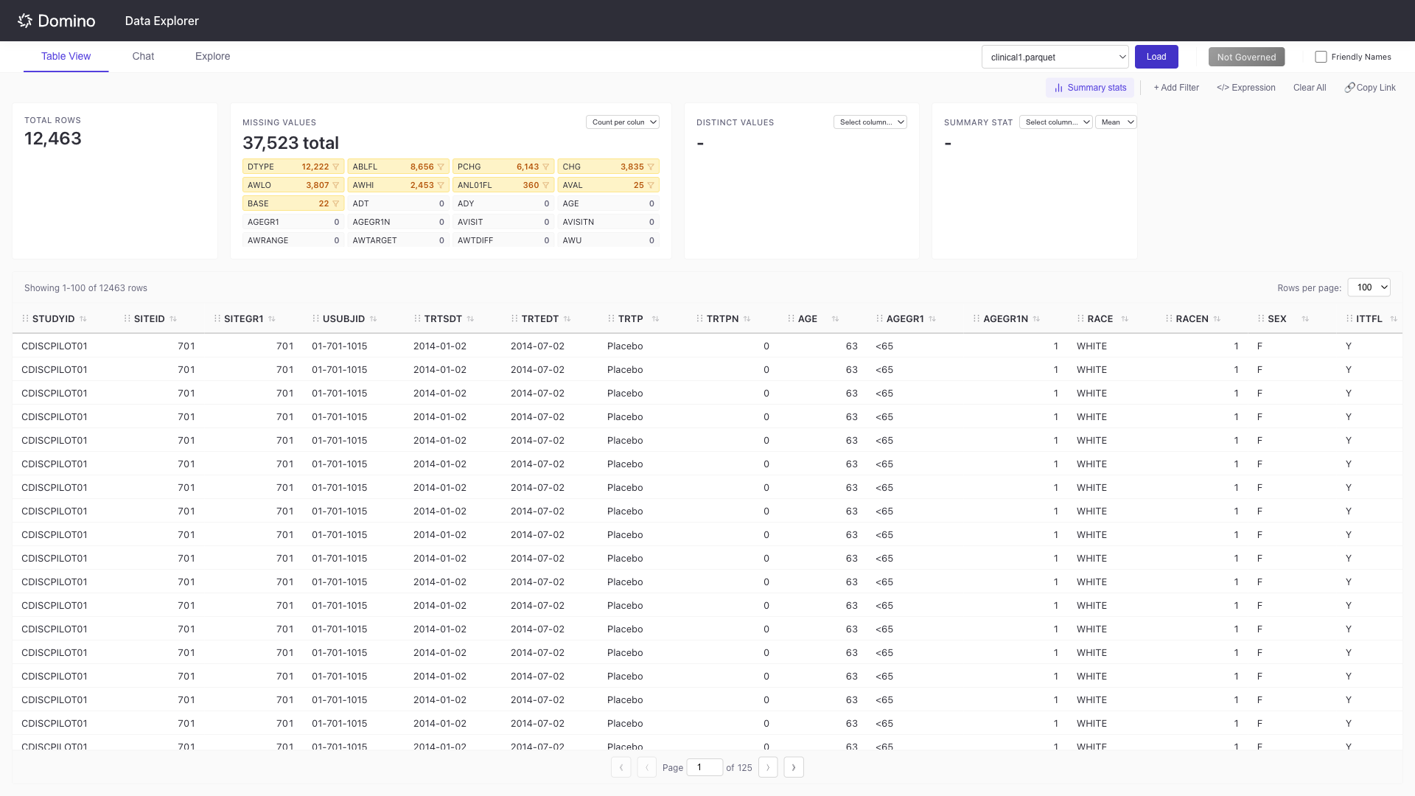
Explore tab showing a histogram alongside a category bar chart:
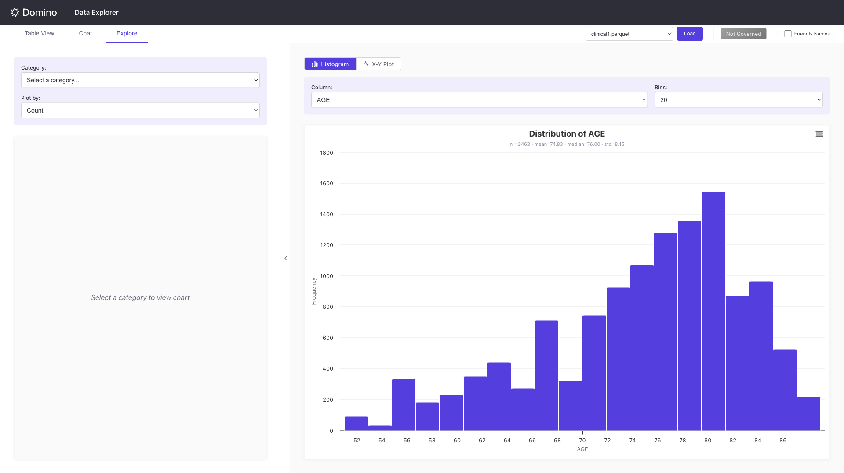
Create Finding for a governed dataset, with the current filtered view captured as a permalink:
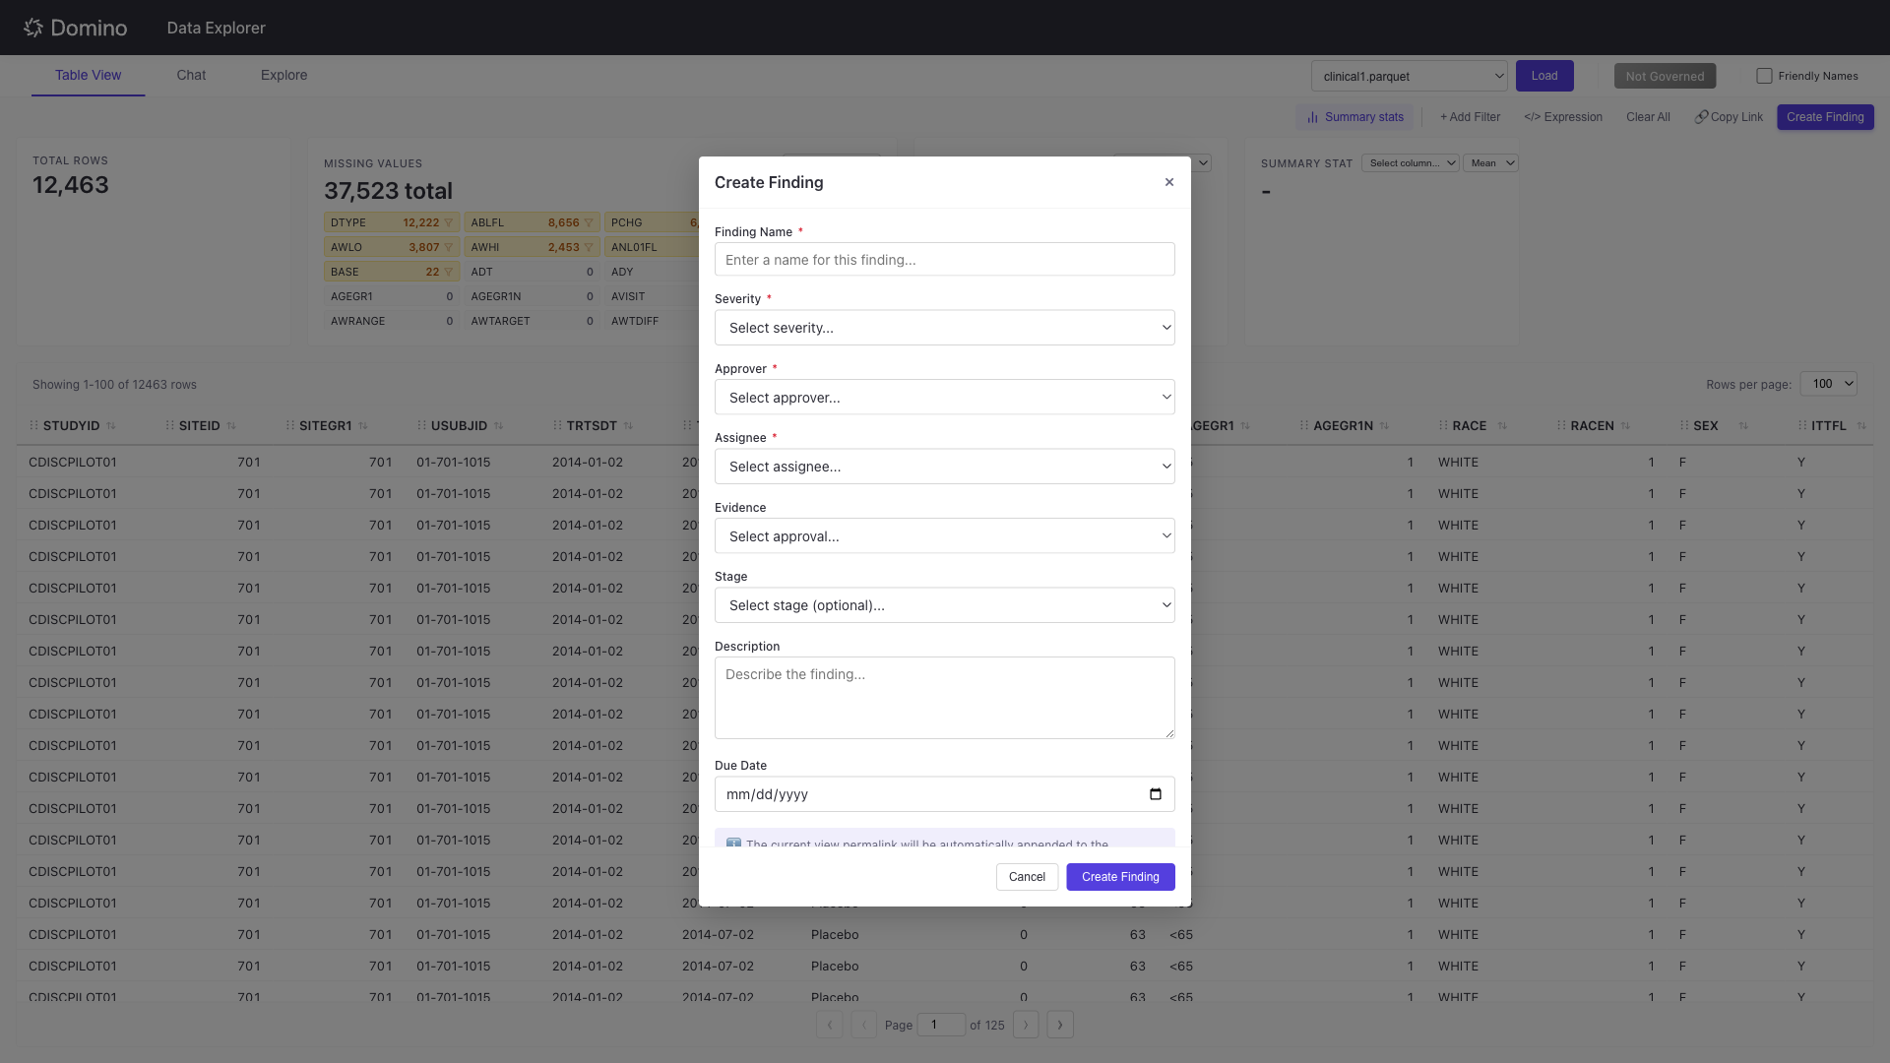

Installation & Setup
Clinical Data Explorer is installed by deploying it as a Domino App and promoting that App to a Domino Extension. The steps below cover a manual production install.

1. Enable Central Config
Enable Extended Identity Propagation so the viewing user’s identity is attached to the requests they send when interacting with the app. Set this Central Config value:
com.cerebro.domino.apps.extendedIdentityPropagationToAppsEnabled=true

2. Create the Domino Environment
- Create a Domino Environment named Clinical Data Explorer using the repository’s Dockerfile.
- Uncheck “Automatically make compatible with Domino.”
- Use the “Required Domino Environment Base Image” from the comment at the top of the Dockerfile as the base image.
- Set the ARG EXTENSION_VERSION to your desired version, then wait for the environment to finish building.

3. Create the Extension Project
Create a Git-backed Project using the public dominodatalab/clinical-data-explorer GitHub repository: https://github.com/dominodatalab/clinical-data-explorer. No credentials are required.

4. Configure Project Environment Variables
- To enable the Chat feature, set the LLM provider variables: LLM_API_KEY, LLM_BASE_URL, and LLM_MODEL. Chat uses OpenAI by default.
- For governance, set DOMINO_API_HOST_OVERD to your Domino deployment URL.
- Cache, session, and dataset-size variables all have defaults. For higher concurrency or larger files, tune values such as MCP_SERVER_DATAFRAME_CACHE_SIZE_B, DATA_FILE_SIZE_LIMIT_B, and DATASET_LOAD_REQUEST_QUEUE_MAX_LENGTH.
- For additional configuration options, see the Advanced Settings section below.

5. Deploy the App
Open the Publish modal and complete the wizard:
- Details: Name the app Clinical Data Explorer and check Enable deep linking and query parameters (required for shareable filter links).
- Code: Select the Git reference matching the EXTENSION_VERSION you set, and set the App file to ./start_servers_prod.sh.
- Deployment: Select the Clinical Data Explorer environment and a hardware tier with 50-100% more memory than MCP_SERVER_DATAFRAME_CACHE_SIZE_B (the Medium tier works with default cache settings). Turn on autoscaling for concurrent use.
- Data: Set Who can View to Anyone in Domino and check Allow App to act for viewers in Domino.
Submit the modal and wait for the App to reach the Running state.

6. Enable the Extension
Open the action menu in the Apps & Agents table and click Create Extension. The extension then appears in the project side bar under the Extensions section.

Troubleshooting
- "No datasets found" - Confirm files exist in the datasets folder and use a supported extension.
- Chat shows "Not Configured" - Set the LLM environment variables; for cloud providers verify LLM_API_KEY.
- Governance features unavailable - Set DOMINO_API_HOST_OVERD and confirm the dataset is attached to an active governance bundle.
- Filters not persisting in links - Ensure "Deep linking and query parameters" is enabled in the Domino App settings.

Advanced Settings
Most installs work with the defaults. Use these settings when you need to support larger datasets, higher concurrency, governance workflows, or a specific LLM provider.

LLM and Chat Configuration
The Chat tab uses an OpenAI-compatible API. By default, the app assumes OpenAI, but it can also point at other providers by changing the base URL and model.
- OpenAI: Set LLM_API_KEY and optionally set LLM_MODEL (for example, gpt-4o). If LLM_BASE_URL is not set, the app uses OpenAI's default API URL.
- Domino LLM Gateway: For customer accounts with Domino's installable LLM Gateway module, point LLM_BASE_URL at the gateway's OpenAI-compatible endpoint, set LLM_MODEL to the gateway model/deployment name, and provide LLM_API_KEY if the gateway requires one. This lets the app use centrally governed models without changing app code.
- Azure OpenAI or other hosted gateways: Set LLM_BASE_URL to the provider's OpenAI-compatible endpoint, then set LLM_API_KEY and LLM_MODEL as required by that provider.
- Local Ollama: Set LLM_BASE_URL to an OpenAI-compatible local endpoint such as http://localhost:11434/v1 and set LLM_MODEL. An API key is not required for local Ollama.
- Chat history: Use CHAT_AGENT_MESSAGE_HISTORY_CACHE_SIZE_B to control the in-memory chat history cache size, and CHAT_AGENT_MESSAGE_HISTORY_CAP to cap how many messages are retained per chat session.

Dataset Size, Caching, and Concurrency
- DATA_FILE_SIZE_LIMIT_B sets the maximum size of an individual data file users can load.
- MCP_SERVER_DATAFRAME_CACHE_SIZE_B controls the in-memory DataFrame cache used after datasets are loaded. For larger datasets, size this to roughly 5x the largest expected file, then multiply by expected active hourly users.
- DATASET_LOAD_REQUEST_QUEUE_MAX_LENGTH limits how many dataset load requests can be queued at once. Increase it for higher concurrent loading, but make sure the selected hardware tier has enough memory.
- DATA_FILE_CACHE_EXPIRATION_SECONDS and DATA_FILE_CACHE_MAX_ITEM_COUNT tune temporary downloaded-file metadata caching. Increase them if creating a DataFrame from selected files takes a long time or many users are active concurrently.
- MCP_SESSION_MAX_AGE and MCP_SESSION_MAX_COUNT control how long loaded dataset sessions stay available and how many sessions are retained.

Production Server Settings
- MAIN_APP_PORT and FLASK_HOST configure the Flask/Gunicorn web app listener.
- MCP_PORT and MCP_HOST configure the MCP FastAPI/Uvicorn server listener.
- MCP_SERVER_URL is the URL the Flask app uses to reach the MCP server. The default assumes both processes run in the same App container.
- FLASK_WORKERS and MCP_WORKERS should generally remain at 1 because request state, MCP sessions, and loaded DataFrames are process-local.
- FLASK_THREADS and GUNICORN_TIMEOUT can be tuned for expected request concurrency and long-running dataset operations.
- LOG_LEVEL can be set to values like DEBUG or TRACE when diagnosing install or runtime issues.

Governance Settings
- DOMINO_API_HOST_OVERD should be set to your Domino deployment URL when governance features are enabled.
- Governance findings require the loaded dataset file to be attached to an active governance bundle and the user to have appropriate permissions for creating findings.

